A

Seminar / Industrial Training / Project

Report on “Name of the Topic”
Submitted in Partial Fulfilment for the award of the Degree of

Bachelor of Technology In
Electrical Engineering



2021-2025
Submitted To: Submitted By:
Mr. Name of student
Head of Department B. Tech, year
RTU Roll No.

ARYA COLLEGE OF ENGINEERING, JAIPUR DEPARTMENT OF ELECTRICAL ENGINEERING

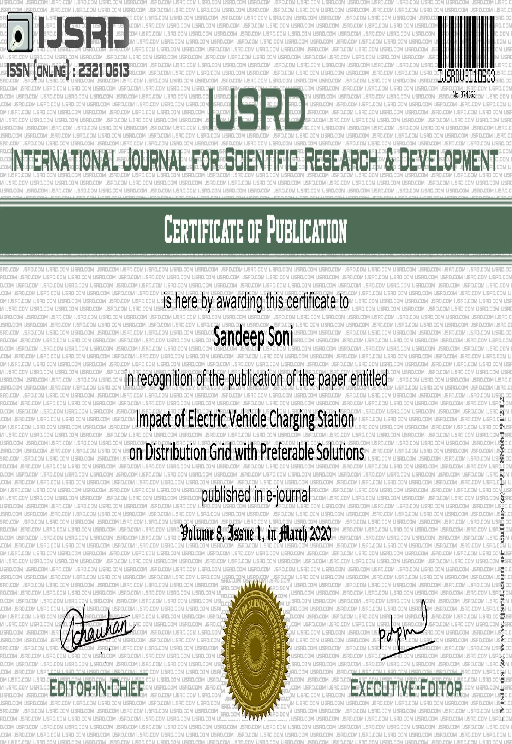

ARYA COLLEGE OF ENGINEERING
SP-40, RIICO Industrial Area, Kukas, Delhi Road, Jaipur Rajasthan – 302028

Department of Electrical Engineering

Certificate

This is to certify that the work, which is being presented in the Practical Training Seminar / Industrial Training / Project report for practical training taken at “Name of company” submitted by Name of Student a student of final year (VIII Sem) B.Tech. in Electrical Engineering as a partial fulfilment for the award of degree of Bachelor of Technology is a record of student’s work carried out and found satisfactory for submission.

Mr.
HOD

DECLARATION
I hereby declare that the work, which is being presented in the seminar entitled Topic Name in partial fulfilment for the award of the degree in Bachelor of Technology in Electrical Engineering, submitted to the Department of Electrical Engineering, Arya College of Engineering, Rajasthan Technical University, is a record of my own work carried under the guidance of Mr. (Name of HOD).
I have not submitted the matter presented in this report anywhere for the award of any degree.

Name – Name of student

Roll no. –

ACKNOWLEDGEMENT
I wish to express my deep sense of gratitude to my Seminar / Training / Project guide Name of guide for guiding me from the inception till the completion of the seminar. I sincerely acknowledge her for giving her valuable guidance, support for literature survey, critical reviews and comments for my seminar.
I would like to first of all express my thanks to Dr. Arvind Agarwal, Chairman of Arya Group of Colleges and Dr. Puja Agarwal, Vice Chairman of Arya Group of Colleges, for providing me such a great infrastructure and environment for my overall development.
I express my sincere thanks to Dr. Surendra Sharma, the Director of Arya Group of College, for his kind cooperation and extendible support towards the completion of my seminar report.
I express sincere thanks to Dr. Himanshu Arora, Principal Arya College of Engineering, for his kind cooperation and extendible support towards the completion of this report.
I also express my deepest thanks to Name of HOD for his support in providing technical guidance and fulfilling my various other requirements for making my seminar successful.
I express my thanks to supporting EE faculty member specially my coordinator name of coordinator / guide who have been a constant source of encouragement for successful completion of the report.
Also my warm thanks to Arya College of Engineering, who provided me this opportunity to carryout, this prestigious seminar and enhance my learning in various technical fields.

Name of student Roll no.-

Table of Content

Title | Page no
Cover Page | i
Certificate (Company) | ii
Certificate (College) | iii
Declaration | iv
Acknowledgement | v
Table of Content | vi
List of Figures | viii
List of Tables | ix
1. Introduction | 1-2
2. Electric drive vehicle | 3-5
2.1 Hybrid electric vehicle | 3
2.2 Plug-in hybrid electric vehicle | 4
2.3 Electric vehicle | 4
3. Battery technologies | 6-8
3.1 Lead batteries | 6
3.2 Sodium batteries | 7
3.3 Lithium batteries | 7
4. Battery management system | 9-14
4.1 Need for BMS | 9
4.2 BMS architecture | 11
4.3 Battery pack design | 12
4.3.1 Cell voltage monitoring | 12
4.3.2 Cell equalisation | 14
5. Protocols | 15-18
5.1 CHAdeMo protocol | 15
6. Charging Infrastructure | 19-31
6.1 Types of charging stations | 21
6.2 Charging Modes | 21

6.2.1 Mode 1 | 22
6.2.2 Mode 2 | 22
6.2.3 Mode 3 | 22
6.2.4 Mode 4 | 22
6.3 AC & DC charging architecture | 23
6.4 Ultra-fast charging architecture | 27
7. Impact on Distribution grid | 32-36
7.1 PHEV characteristics and assumptions | 33
7.1.1 PHEV battery capacity | 34
7.1.2 State of Charge | 35
7.1.3 Charging Level | 35
7.1.4 Load Growth | 36
7.1.5 PHEV Distribution in the Network | 36
8. EV Load Classification | 37-41
- The Scale of EV access  - Operational Parameter of Distribution grid | 37  38
- Voltage profile | 38
8.2.2 Reliability | 39
8.2.3 Power Losses | 39
8.3 Optimisation of home charging and | 39
Renewable energy
9. Topology of BMS | 42-46
9.1 Control | 42
9.1.1 BMS Control | 43
9.1.2 Charge | 44
9.1.3 Discharge | 44
9.3 Charging Solution | 44
Reference | 47

List of Figures

S. No. | Figure Name | Page No.
1 |  | 3
2 |  | 4
3 |  | 10
4 |  | 12
5 |  | 14
6 |  | 15
7 |  | 16
8 |  | 17
9 |  | 18
10 |  | 20

List of Tables

S. No. | Table Name | Page No.
1 |  | 20
2 |  | 23
3 |  | 34
4 |  | 34
5 |  | 37
6 |  | 40

General instructions about preparation of training report

Paper: A4

Font: Times New Roman, Bookman Old Style

Chapter Heading: 16pt, Sub heading: 14, Sub-Sub Headings: 12 Bold Running Matter: 12 pt
All topics should be numbered accordingly. Paragraph Gap: 6 Pt Maximum
Line Gap: 1.5

Margins: Left 1.5, Right, Top and Bottom 1 inch

All diagrams/figures and tables should be appropriately numbered.

Please note

- An electronic presentation has to be prepared for the Industrial Training / Project / Seminar.
- The presentation should be of around 15-20 mins. duration, with 5 mins. for question answers.
- The number of slides should be prepared accordingly.
- A CD of the presentation should be submitted with the report.
- The reports should be
  - Hard bound with plain faint blue cover page for Industrial Training,
  - Hard bound with a black cover with golden printing for Project Report,
  - and Spiral binding for seminar report.
- The format for the report should be strictly adhered to.
- The report should focus on the work carried out by the student.
- Company profile and overall project summary should not exceed five pages.

